Application form for Permanent Identity Card

(To be filled by the applicant)

To,

The Development Commissioner, NSEZ

NOIDA Dadri Road, Phase-II, NOIDA-201-305

Dist.: Gautam Budh Nagar (UP)

Candor Gurgaon One Realty Projects Pvt. Ltd (Developer)

Special Economic Zone (IT/ITES)

Vill Tikri, Sector-48, Gurgaon-122002 Haryana

Name of Company/Unit : EVALUESERVE.COM PVT. LTD

Name of the Employee : Pranjal Tyagi

Employee Code : ________________________________________

Designation : Junior Analyst

Father’s / Husband Name : Sanjay Tyagi

Temporary Residence : #83-84, Green Park Phase-1, Yamuna Nagar,

Haryana, India

________________________________________

Permanent Residence : #83-84, Green Park Phase-1, Yamuna Nagar,

Haryana, India

________________________________________

Date of Birth : 06-05-2002

Date of Joining : 01-08-2024

Identification Mark : Mole on Chin

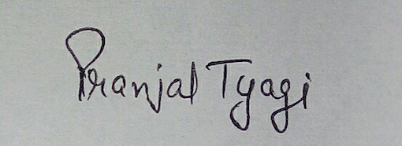

------------------------------ -----------------------------------------

Signature of Employee Signature of Authorized Signatory

(With Name and Seal)

**(For office use only)**

Entry for Mr./Ms./Mrs. _______________________________________ S/o /D/o/ W/o Shri ________________________________ has been made in the register of M/s Candor Gurgaon One Realty Projects Pvt. Ltd., Developer (Special Economic Zone) located at Vill .Tikri, Sector-48, Gurgaon-122002 Haryana at Sr. No.________ at Page No. ______. Now Mr. / Ms. / Mrs. ______________________________is allowed to get entry in M/s Candor Gurgaon One Realty Projects Pvt. Ltd., (Special Economic Zone) by showing his Permanent Identity Card.

__________________________________

(Signature of Development Commissioner)

**Extra details for ID Card creation:**

Blood Group:   
 

Mobile No. (10 Digit) 

Emergency Contact No’s. 

(It should be Parents/Spouse Nos.)